弘光科技大學學位論文延後公開申請書
Hungkuang University Application for Embargo of Thesis/Dissertation
申 請 日 期：民國 年 月 日
Application Date: / / (YYYY/MM/DD)
姓 名  Name |  | 學位類別  Graduate Degree | ☐碩士Master  ☐博士Doctor | 畢業年月  Graduation Date  (YYYY/MM) |  | 民國 年 月  /
系所名稱
School/Department
論文名稱
Thesis /
Dissertation Title
延後公開原因  Reason for  embargo | ☐涉及機密  Confidential information  ☐專利事項  Patent matters  ☐依法不得提供  Not permitted to be provided on statutory grounds
申請項目  Options | ☐紙本論文及電子全文延後公開  Delay public access to the printed and  electronic copies of my thesis, but leave the  online bibliographic record open to the public. |  | 公開日期  Delayed Until |  | 民國 年 月 日  / / (YYYY/MM/DD)
申請人簽名：  Applicant Signature: ____________________ |  |  | 指導教授簽名：  Advisor Signature: ____________________
學校認定/  審議單位章戳：  Seal of the  Authorization Institute: | 考試委員 | 系主任 | 學院院長 | 教務長

【說明】
- 依教育部107年12月5日臺教高(二)字第1070210758號函、109年3月13日臺教高通字第1090027810號函、112年2月14日臺教高(二)字第1122200197號函、114年6月4日臺教高通字第1142201506號函，請據實填寫並檢附由學校權責單位認定之證明文件，經由學校向本館提出申請，無認定單位簽章者將退回學校處理。
- 延後公開之學位論文送存本館時，應將延後公開申請書及相關證明文件，併同紙本論文及電子全文檔送存。
- 依教育部114年6月4日臺教高通字第1142201506號函有關學位論文延後公開（一定期間不予公開）機制，每次申請紙本論文及電子全文延後公開至多為5年，且需逐次申請；第2次起之申請程序，仍應取得原所有學位考試委員審核確認，或經原就讀系所之系（所）務等會議審核確認，經由學校向本館提出申請。
- 論文已送達國家圖書館者，有申請延後公開之需求，須經由學校發函，並將延後公開申請書及相關證明文件提送本館申請。
【Notes】
- According to the announcements made by the Minister of Education, please fill in all blanks and attach the certification documents approved by the university and apply through the university. The application form will not be accepted for processing until all information, signatures, and seals/signature are included.
- If the thesis or dissertation is not yet submitted to the NCL, the signed application form and the certification documents shall be submitted with both the printed and electronic full-text file of the thesis or dissertation.
- According to the Ministry of Education’s directive on the thesis/dissertation embargo mechanism, each embargo period shall not exceed five (5) years from the date of application. From the second application onward, approval must be reconfirmed by all original degree examination committee members or by the departmental (or institute) affairs meeting of the applicant’s original academic unit.
- If the thesis or dissertation has been submitted to the NCL, the university should send an official letter with the signed application form and certification documents to apply for embargo.

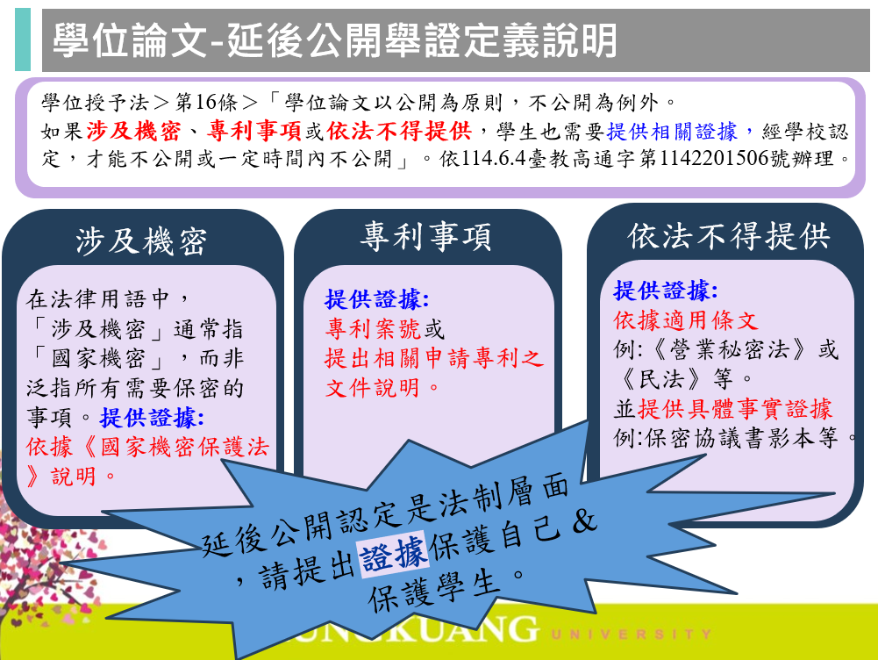
佐證文件請拿出實質證據，例如:專利申請號、申請專利之文件、與研究合作機關簽署的保密協議等文件。

